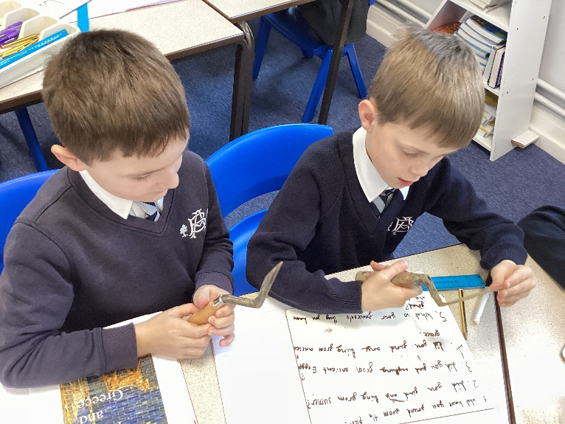
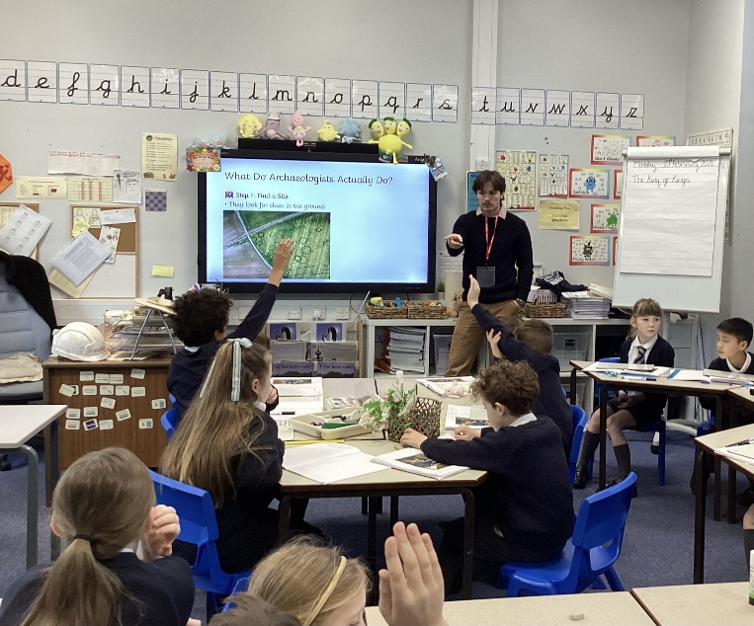
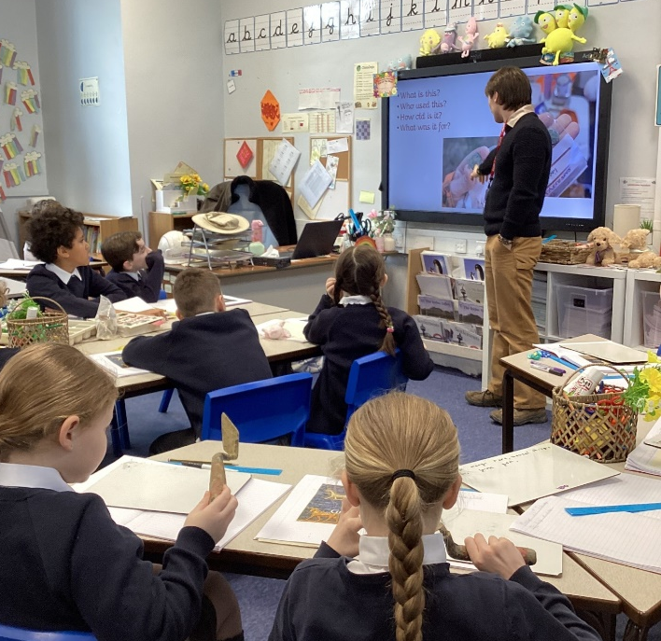
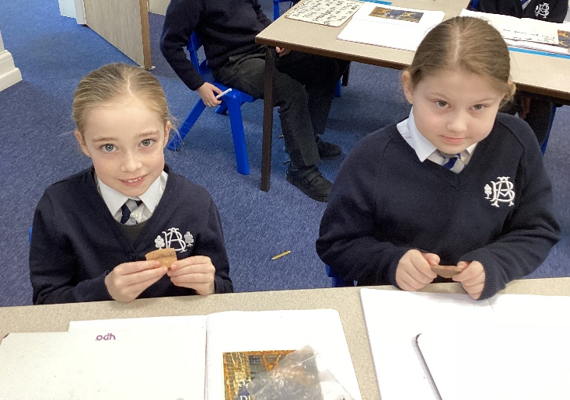
23/02/26
Today a special visitor came to talk to us about archaeology. We learned a lot about what an archaeologist does, and how we can become archaeologists when we are older. We also learned the difference between archaeology and palaeontology.
We got to handle potsherds and digging tools, and we asked our guest archaeologist lots of interesting questions!

